***System Design***

There are 5 modules in this program

* First module: Sign-in [ Here the user will have to sign in to operate the system].
* Second module: Fill up form [Here the user will need to fill up the form with the essential detail of the costumer].
* Third module : Movie Selection page [here the user need to select the movie of his/her choice ;with the selection of the show timings provided and the dates given].
* Fourth module : Selection of seats [The user needs to select the seats of his/her choice].
* Fifth module: The receipt [Here the costumers receipt will be displayed and with the help of print option the user will be able to print the receipt].

This program has been made using Graphical User Interface (GUI).

About GUI

The graphical user interface is a form of user interface that allows users to interact with electronic devices through graphical icons and audio indicator such as primary notation, instead of text-based user interfaces, typed command labels or text navigation.

***Classes made:***

1. **Loginloading.java**
2. **Loading.java**
3. **Informationdata.java**
4. **Splash.java**
5. **Movieselection.java**
6. **Seatreservation.java**
7. **Print.java**
8. **Main.java**

**1.Loginloading**

This class includes Login form where it includes filling up of User’s Login details

Then there is are action buttons which are used to jump on different pages like fill up form; home page; submit button.

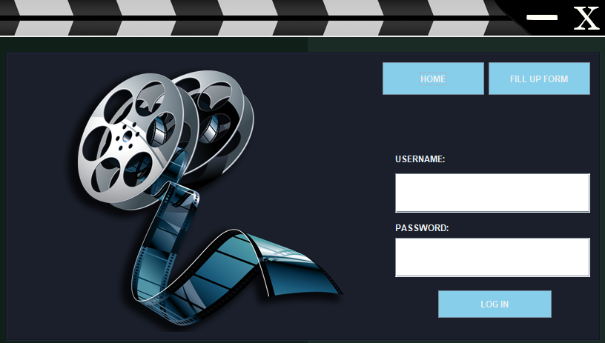

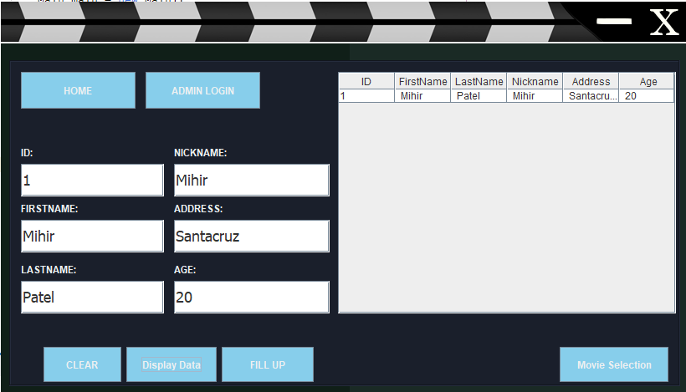

**2. Loading.java**

This class includes a loading screen which give a good graphical interface

This class includes a jar file which is included in the library

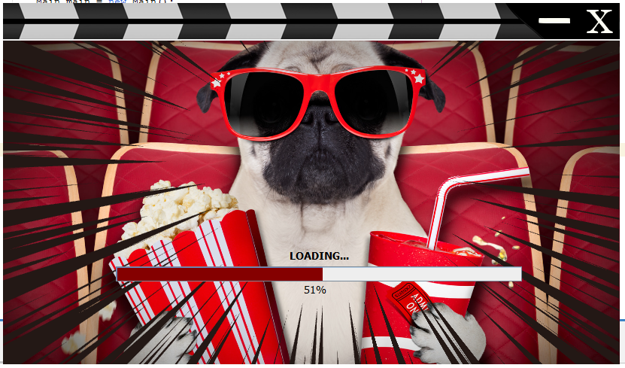

**3.Informationdata.java**

This class includes information data

**4. Movieselection.java**

In this class the user will be able to select the movies of his/her choice

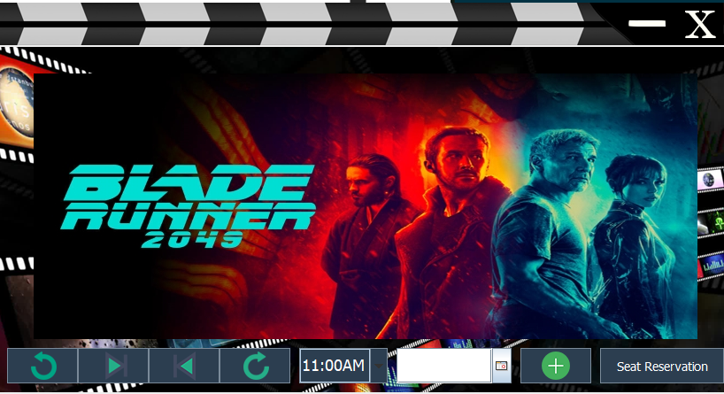

**5.seatreservation.java**

**This class includes the seats**

**In this the user will be able to choose the seat of his/her choice**

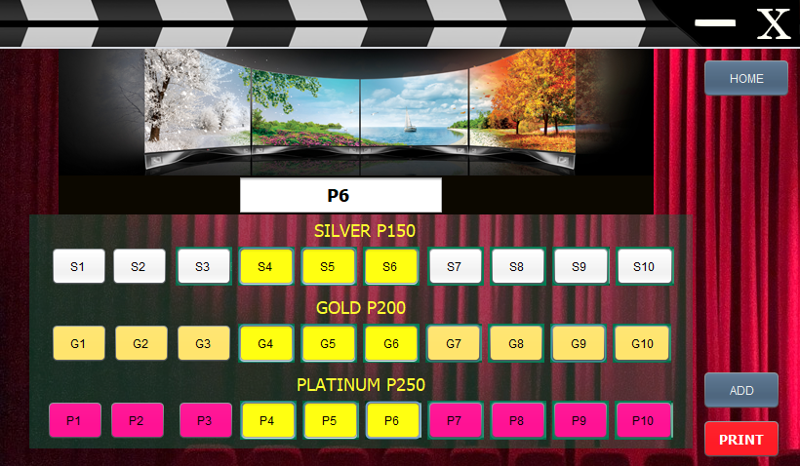

**6.print.java**

**This class print displays the receipt and with the help of the print option the user will be able to print the receipt**

